CSIT751 (Core Java)
Module I – Introduction to Java
Programming Exercises for Practice (Practical Home Assignment 1)

Task 1:
Write a program that declares variables for a student’s name, roll number, and marks in three
subjects. Assign values and print them. Ensure all variable names follow Java identifier rules.
Program :
class Main {
public static void main(String[] args) {
String studentName="Sam";
int studentRollno=31;
int subjectEnglish=92;
int subjectMaths=80;
int subjectScience=77;
System.out.println("Student name : "+studentName);
System.out.println("Student rollno. : "+studentRollno);
System.out.println("English marks : "+subjectEnglish);
System.out.println("Maths marks : "+subjectMaths);
System.out.println("Science marks : "+subjectScience);
}
}

Output :
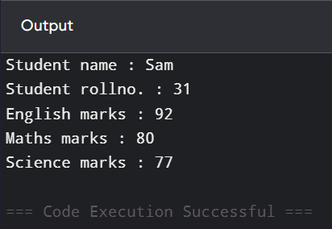
Task 2:
Write a Java program that:
• Stores an integer value for temperature in Celsius.
• Converts it to Fahrenheit using the formula F = (C × 9/5) + 32.
• Displays both Celsius and Fahrenheit values.
Program :
public class Fahrenheit {
public static void main(String[] args) {
float celsius=91.02f;
float fahrenheit=(celsius*9/5)+32;
System.out.println("Temperature in degree Celsius : "+celsius);
System.out.println("Temperature in degree Fahrenheit : "+fahrenheit);
}
}

Output:
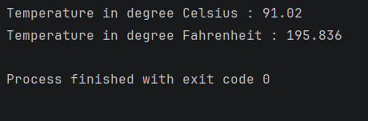
Task 3:
Accept two integers from the user and perform addition, subtraction, multiplication, division, and
modulus. Display results for each operation.
Program :
import java.util.*;
class Operations {
public static void main(String[] args) {
Scanner sc=new Scanner(System.in);
System.out.print("Enter number 1 : ");
int a =sc.nextInt();
System.out.print("Enter number 2 : ");
int b=sc.nextInt();
System.out.println("Addition : "+(a+b));
System.out.println("Subtraction : "+(a-b));
System.out.println("Multiplication : "+(a*b));
System.out.println("Division : "+(a/b));
System.out.println("Modulus : "+(a%b));
}
}
Output :
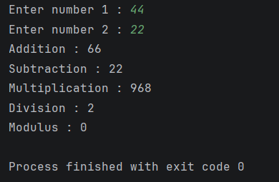

Task 4 :
Write a program to check if a person is eligible to vote.
• Input: age and citizenship status (true or false).
• Use logical operators (&&, ||) to decide eligibility.
Program :
import java.util.*;
public class Eligibility {
public static void main(String args[]){
Scanner sc = new Scanner(System.in);
System.out.print("Enter your age : ");
int age=sc.nextInt();
System.out.print("Are you a citizen? (True/False) : ");
boolean citizen=sc.nextBoolean();
if(age>=18 && citizen==true){
System.out.println("You are eligible to vote.");
}else{
System.out.println("You are not eligible to vote.");
}
}
}

Output :
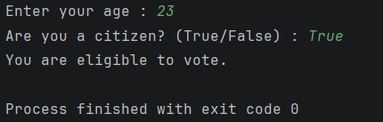
Task 5:
Write a program that:
• Takes two numbers and an operator symbol (+, -, *, /) from the user.
• Uses if-else statements to perform the appropriate operation.
Program :
import java.util.*;
public class Operator_Test {
public static void main(String args[]){
Scanner sc=new Scanner(System.in);
System.out.print("Enter number1 :");
double num1=sc.nextDouble();
System.out.print("Enter number2 : ");
double num2=sc.nextDouble();
System.out.print("Enter an operator (+,-,*,/) : ");
char operator=sc.next().charAt(0);
if(operator=='+'){
System.out.println("Result : "+(num1+num2));
}else if(operator=='-'){
System.out.println("Result : "+(num1-num2));
}else if(operator=='*'){
System.out.println("Result : "+(num1*num2));
}else if(operator == '/'){
if(num2!=0) {
System.out.println("Result : " + (num1 / num2));
}else{
System.out.println("Cannot divide by zero");
}
}
}
}

Output :
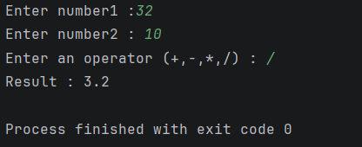
Task 6:
Ask the user for a number and print its multiplication table from 1 to 10 using a for loop.
Program :
import java.util.*;
public class Multiplication_Table {
public static void main(String[]args){
Scanner sc=new Scanner(System.in);
System.out.print("Enter a number : ");
int n=sc.nextInt();
for(int i=1;i<=10;i++){
int t=0;
t=n*i;
System.out.println(n+"*"+i+"="+t);
}
}
}

Output :
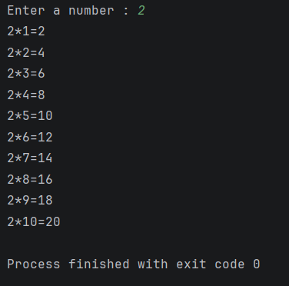
Task 7:
Write a program that uses a while loop to find the sum of all even numbers between 1 and 50.
Program :
public class Sum_Of_Even {
public static void main(String[]args){
int i=1;
int sum=0;
while(i<=50){
if(i%2==0){
sum+=i;
}
i++;
}
System.out.print("Sum of Even numbers between 1 to 50 : "+sum);
}
}
Output :
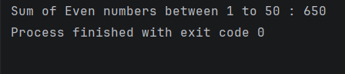
Task 8:
Write a program that:
• Reads marks of 5 students into an integer array.
• Prints each student’s marks.
Program :
import java.util.*;
public class Student_Marks {
public static void main(String[]args){
Scanner sc=new Scanner(System.in);
int[] marks=new int[5];
for(int i=0;i<5;i++){
System.out.println("Enter the marks of student "+(i+1)+": ");
marks[i]=sc.nextInt();
}
for(int i=0;i<5;i++){
System.out.println("Student "+(i+1)+" Marks : "+marks[i]);
}
}
}
Output :
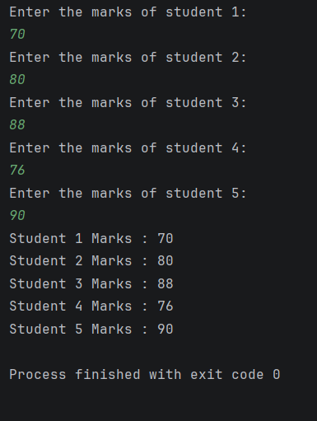
Task 9:
Write a program to read 10 integers into an array and find the maximum value using a loop.
Program :
import java.util.*;
public class Max_Array_Number {
public static void main(String[]args){
Scanner sc=new Scanner(System.in);
int[] arr= new int[10];
for(int i=0;i<10;i++){
System.out.print("Enter the array element["+i+"] : ");
arr[i]=sc.nextInt();
}
//assuming 1st element as maximum
int max=arr[0];
for(int i=0;i<10;i++){
if(max<arr[i]){
max=arr[i];
}
}
System.out.print("Maximum Number : "+max);
}
}

Output :
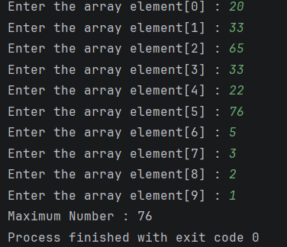
Task 10:
Write a program that:
• Reads marks of 5 subjects into an array.
• Calculates the average marks.
• Uses if-else to assign grades:
o >= 90: A
o >= 75: B
o >= 50: C
o Else: Fail
Program :
import java.util.*;
public class Subjects {
public static void main(String[]args){
Scanner sc=new Scanner(System.in);
int[] sub=new int[5];
int sum=0;
for(int i=0;i<5;i++){
System.out.print("Enter the marks of subject "+(i+1)+" : ");
sub[i]=sc.nextInt();
sum+=sub[i];
}
double avg=sum/5.0;
System.out.print("Average marks: "+avg);
if(avg>=90){
System.out.print("Grade A");
}
else if(avg>=75){
System.out.print("Grade B");
}
else if(avg>=50){
System.out.print("Grade C");
}else{
System.out.print("Grade = Fail");
}
}
}
Output :
